

Relationship and Sex Education (RSE) Policy

Date approved: May 2024
Review date: Summer 2027

ST MARK’S SCHOOL VISION AND VALUES
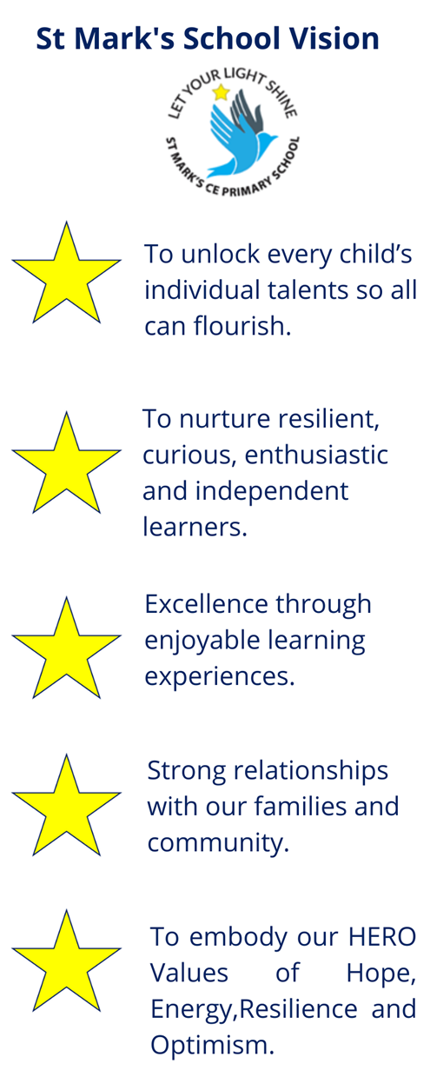

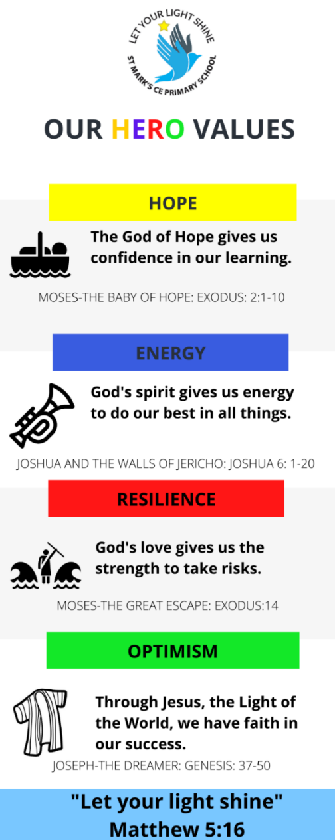
ST MARK’S SCHOOL VALUES

At St. Mark’s we are very proud of our staff’s commitment and dedication to ensure that all of the children within our care receive a high quality education. We believe in the concept of lifelong learning and the idea that both adults and children learn new things every day. Learning should be a rewarding and enjoyable experience for everyone; it should be fun.
We conduct all our teaching in an atmosphere of trust and respect for all, in line with our distinctive Christian tradition.
We pride ourselves on being a family school.
We recognise that every child is unique and our skilled staff ensure that every child receives a rich learning experience that ensures they reach their full potential, within our Christian ethos of support and high expectations.
Our children are at the heart of everything that we do. We strive to nurture their natural curiosity, creativity and enthusiasm for learning-and vow to hold on to those qualities all the way up to Year 6, through our engaging curriculum.
Through our HERO Learning Powers-Hope Energy Resilience and Optimism, we prepare our children for life-long learning that goes beyond the classroom. We want all of our children to believe in themselves and rise to any challenge they may face.

Our “HERO Learning Values” should:

- Be visible in each classroom – on display and talked about with pupils.
- Be referred to at the start, at the end and during lessons.
- Become part of everyday language in school
- Be used to reinforce positive learning behaviours with all classes.
- Be used as an important part of pupils’ reflection and review time.
- Be used with individuals to encourage specific behaviours like resilience, challenge and motivation.

We live our vision every day "Let Your Light Shine!" Matthew 5:16



This policy links with other school policies including the Anti-bullying Policy, Personal, Social, Health & Economic Education (PSHE) Policy, Equalities Policy, Safeguarding Policy, Confidentiality Policy and Health and Safety Policy.

Relationship and Sex Education Policy

Mission Statement

We conduct all our teaching in an atmosphere of trust and respect for all, in line with our distinctive Christian tradition. We pride ourselves on being a family school where we are respectful and kind to everyone despite our unique differences. Our school motto of ‘Let your light shine’ is embedded in everything we do and we encourage children to celebrate their uniqueness and shine alongside eachother.
Introduction

Relationship and Sex Education (RSE) will become statutory in all primary schools in England from September 2020. Health education will also become statutory in all state-funded schools.

This Policy has been written within the context of upholding strong Christian Family Values as being the heart of all that we do for the children and families of St.Mark’s Primary School. Through our whole school Ethos and Mission Statements to serve our families in this community we ensure that all children are provided with and RSE education that is accepted within the Christian Faith. By making links with baptism, confirmation and marriage celebrations in both the teaching of Religious Education (RE) and topic work we positively promote an understanding of Christian family life. It is also important that as a Christian school we need to be sensitive to the needs of our diverse community and show empathy and understanding to all families. Pupils also need to understand that there are strong and mutually supportive relationships outside of marriage. We try to ensure that no stigma is placed on children based on their home circumstances. We aim to provide accurate information and to help to develop skills to enable them to understand differences and respect themselves and others, thus preparing them for the responsibilities and experiences of adult life. We hope to prevent and remove prejudice. We will work towards this aim in partnership with parents/carers.

At St Mark’s School, Relationship and Sex Education is an integral part of the personal, social and health education curriculum, preparing our pupils to become confident and informed young people, able to make informed choices in relationships, while maintaining the ethos of a Church Aided school. This policy is applied in line with our Equality, Anti-bullying and Child Protection Policies.

RSE is learning about the emotional, social and physical aspects of growing up, relationships, sex, human sexuality and sexual health. Some aspects are taught in science and others are taught as part of Personal, Social, Health and Education (PSHE).

RSE is an important part of a child’s education and is designed to equip them with accurate information, essential skills and confidence to grow, learn and develop positive, healthy behaviour to manage their lives as they move through puberty towards adulthood. It also gives children and young people essential skills for building positive, enjoyable, respectful and non-exploitative relationships and staying safe both on and offline.

This policy is designed to prepare all pupils for the future, regardless of sexual orientation or gender identification. RSE promotes gender equality and LGBT+ (Lesbian, Gay, Bisexual, Transgender and related communities) equality and challenges discrimination. It takes the needs and experiences of LGBT+ people into account and seeks to develop understanding that there are a variety of relationships and family patterns in the modern world.

Aims and Objectives
Relationship and Sex Education, as part of the Science and PSHE Curriculum (including statutory health education), consists of three main strands: attitudes and values, personal and social skills, and knowledge and understanding. We teach, in accordance with The Church of England and RSE Guidance, pupils appropriately to their age, about:
- Developing self-awareness and respect for their own bodies
- Developing communication and decision making skills
- Understanding their responsibilities within personal relationship issues
- The physical development of their bodies as they grow into adults and the emotional changes that can occur
- The way humans reproduce
- The nature of stability in relationships and its importance to family life
- The importance of positive body image and how the media can affect this
- To keep safe online
- The importance of sexual activity as part of a long-term committed relationship
- Exploring related values, attitudes and moral questions and respecting the views of other people
- What they should do if they are worried about any sexual matters

Context
We teach RSE in the context of the school’s aims and advice from the Department of Education (DFE) and Church of England. RSE in our school means that we give pupils information about families and people who care for them, caring friendships, respectful relationships, online relationships, being safe and sexual behaviour, we do this with an awareness of the Christian ethos which underpins all our work in school. In particular, we teach RSE in the belief that:
- Children should be taught to have respect for their own bodies
- Children should learn about their responsibility to others, and be aware of the consequences of their actions
- It is important to build positive relationships with others, involving trust, respect and commitment
- Children need to learn the importance of self-control
- Relationship and Sex education should be taught in the context of stability in relationships; Relationship and Sex education is part of a wider social, personal, spiritual and moral education process

The Organisation of RSE
We teach RSE through different aspects of the curriculum Science and PSHE Curriculum, including statutory health education. This happens during a sequence of lessons which combine science and PSHE. Our RSE curriculum is based on the Brighton and Hove PSHE curriculum and on the Brighton and Hove lesson overview.

The scheme of work for RSE at St.Mark’s Primary School maps out a grid of lessons/units for each year group which progresses and returns to themes as children move through the school.
For example: Family and Relationships:
Reception: Family Networks
Y1: Family
Y2: Everybody Needs Caring For
Y3: Family Differences
Y4: Changing Relationships
Y5: Building Good Relationships
Y6: Being a Good Parent (See appendix A for further details).
We also teach RSE through other subject areas (eg Science, Physical Education(PE) and Religious Education(RE)), where we feel that they contribute significantly to a child’s knowledge and understanding of his or her own body, and how it is changing and developing. Linked with R.E. children reflect on family relationships, different family groups and friendship. They learn about rituals and traditions associated with birth, marriage and death and talk about the emotions involved.
Since SRE incorporates the development of self-esteem and relationships, pupils’ learning does not just take place through the taught curriculum but through all aspects of school life including the playground. It is important then that all staff understand they have a responsibility to implement this policy and promote the aims of the school at any time they are dealing with children.
Other aspects of the curriculum may also be covered in science, PSHE and PE lessons. Generally, PSHE and science lessons discussing RSE will be taught as a whole class, with boys and girls together. Occasionally boys and girls may be separated to discuss specific issues (particularly during some of the Year 5/6 lessons which discuss changes during puberty) but the coverage will be the same. A teacher may break the class into smaller groups within the class or speak to an individual as appropriate. However, most lessons will be taught to both boys and girls to ensure a good understanding of these areas for both genders.

From KS2, we place a particular emphasis on health education, as many children begin to experience puberty at this age. We liaise with the Local Authority about suitable teaching materials to use with our pupils in these lessons. We keep in regular contact with the Local Authority about any changes, updated information or resources to ensure children receive high quality teaching. Teachers do their best to answer all questions with sensitivity and care. By the end of Key Stage 2, we ensure that both boys and girls understand that happy, healthy relationships take many forms, know how babies are born, how their bodies change during puberty, what menstruation is, and how it affects women. We also explore body image and how the media can affect this and how to keep safe online. We always teach this with due regard for the emotional development of the children.

In Early Years Foundation Stage children learn about life cycles. Through on-going personal, social and emotional development they develop the skills to form relationships and think about relationships with others.
In Key Stage 1 children learn:

- That animals including humans, move, feed, grow and use their senses and reproduce
- To recognise and compare the main external parts of the bodies of humans
- That humans and animals can reproduce offspring and these grow into adults
- To recognise similarities and differences between themselves and others
- To treat others with sensitivity

In Key Stage 2 children learn:

- That the life processes common to humans and other animals including nutrition, growth and reproduction
- About the main stages of the human life cycle

In Year 5 we place a particular emphasis on RSE, as many children experience puberty at this age. We teach the children about the parts of the body and how they work. We also explain what will happen to their bodies during puberty. We encourage the children to ask for help if they need it and there are opportunities for single gender question sessions. Teachers do their best to answer all questions with sensitivity and care. By the end of Key Stage 2, we ensure that both boys and girls know how babies are born, how their bodies change during puberty, what menstruation is, and how it affects women. We always teach these with due regard for the emotional development of the children (as stated earlier in this policy).
The school will also be responsive to issues and concerns that arise from pupils on a day to day basis. If appropriate, parents will be informed about such cases.

The Role of Parents and Carers
The school is well aware that the primary role in children’s RSE lies with parents and carers. We wish to build a positive and supportive relationship with the parents and carers of the pupils at our school through mutual understanding, trust and co-operation. In promoting this objective we will:
- Consult parents and carers about the school’s Relationships and Sex Education policy and practice
- Inform parents and carers about the topics planned to be covered in Relationship and Sex Education, including puberty, menstruation and relationships
- Answer any questions that parents and carers may have about the Relationship and Sex Education of their child
- Take seriously any question that parents and carers may have about the Relationship and Sex Education of their child
- Support parents and carers in teaching their children about Relationship and Sex Education growing up
- Encourage parents and carers to be involved in reviewing the school policy and making modifications to it as necessary
- Inform parents and carers about the best practice known with regard to Relationship and Sex Education, so that the teaching at school supports the key messages that parents and carers give to children at home

We believe that, through this mutual exchange of knowledge and information, children will benefit from being given consistent messages about their changing body and their increasing responsibilities.

Relationships Education is compulsory for all pupils receiving primary education. Parents and carers have the right to withdraw pupils from sex education but not Relationships or Health Education. If a parent wishes their child to be withdrawn from the sex education element of RSE lessons, they should discuss this with the Head teacher, making it clear which aspects of the programme they do not wish their child to participate in. We will keep a record of who has been withdrawn from lessons.

The Role of Other Members of the Community

We encourage other valued members of the community to work with us to provide advice and support to the children with regard to health education. In particular, a member of the Local Health Authority, such as the school nurse, gives us valuable support with our Relationship and Sex Education programme. Other people we may call on include local clergy, social workers and youth workers.

The Role of the Teacher
Teachers conduct Relationship and Sex Education lessons in a sensitive manner and in confidence but cannot offer pupils unconditional confidentiality. Teachers should inform the Designated Safeguarding Lead/ Deputy Designated Safeguarding Lead or Deputy or Head-teacher, then parents or the school nurse as appropriate over issues that may be raised. If a pupil makes a reference to being involved in, or a likelihood of involvement in, sexual activity, then the member of staff will take the matter seriously and deal with it as a matter of child protection following school policy. Staff will respond in a similar way if a child indicates that they may have been a victim of abuse. In these specific cases the member of staff will refer the matter to the Designated Safeguarding Lead (DSL) or Deputy DSL if there is a genuine concern. The DSL or Deputy DSL will then deal with the matter in consultation with other professionals in accordance with our Child Protection Policy. All staff are expected to work within this policy. Teachers and other staff need to help children develop confidence in talking, listening and thinking about issues to do with Relationship and Sex Education. Teachers and other staff can use a range of strategies to help them do this, including establishing clear ground rules, introducing ‘distancing’ techniques, making use of discussion and drama and encouraging reflection.

The Role of the Head Teacher
It is the responsibility of the Head teacher to ensure that both staff and parents are informed of our Relationships and Sex Education Policy, and that the policy is implemented effectively. It is also the Head teacher’s responsibility to ensure that staff are given sufficient training, so that they can teach effectively and handle any difficult issues with sensitivity. The Head teacher oversees the involvement of external agencies regarding the school Relationship and Sex Education Programme, and ensures that all adults who work with children on these issues are aware of the school policy and that they work within this framework. The Head teacher and governors monitor the effectiveness of this policy regularly.

The Role of Governors
- Governors are responsible for agreeing a whole school approach to RSE.
- Governors are responsible for deciding at what stage to offer RSE and ensuring any arrangements comply with the law.
- Governors must agree a written policy for RSE which should be reviewed at least every three years by the full governing body.
- In drawing up the policy for RSE, governors should ensure it reflects the Christian ethos of the school. This means that RSE will reflect the Christian beliefs, values and attitudes of the school community; with an emphasis on the importance of marriage, the family and stable relationships to build a child’s self-esteem, self-awareness and a sense of moral responsibility. These beliefs and values should permeate the life and work of the school and the RSE policy should also reflect the school’s vision as a church school.
- Governors should ensure that the RSE policy is linked to other relevant policies, in particular policies concerned with promoting the welfare and safeguarding of pupils.
- In drawing up the RSE policy governors should involve parents/carers and pupils to ensure it meets the needs of the pupils.
- Governors should ensure that a copy of the RSE policy is accessible to all parents/carers.

Special Educational Needs and Disabilities (SEND) and Vulnerable Pupils
Our pupils have different abilities based on their emotional and physical development, life experiences, literacy levels and learning needs, but we will aim to ensure that all pupils are properly included in RSE.
Some pupils with SEND may be more vulnerable to abuse and exploitation than their peers, and others may be confused about what is acceptable public behaviour. These pupils in particular will need to develop skills to reduce the risks of being exploited, and to learn what sorts of behaviour are, and are not acceptable. A supportive, nurturing and caring environment within the classroom provides a platform to support all our pupils. It is helpful to remember to focus on activities that increase a pupil’s assertiveness, communication and relationship skills, their self-esteem and understanding.

Dealing with Questions
The teaching of RSE will have a set of ground rules providing boundaries over what is appropriate and not appropriate, and about how to respond to unexpected, embarrassing questions or comments from pupils in a whole class situation.
- Questions will be answered in an honest and age appropriate way which offers clarity and avoids confusion.
- Teachers will reply to, and answer, children’s questions sensitively and openly. They will ensure that balanced information is provided which will take into account the different faiths’ views and avoid any negative impressions.
- Teachers will need to answer questions that may arise through the direct teaching of sex education, as well as those that may be asked at other times. All questions will be handled sensitively and set within a general context.
- Questions which teachers feel uncertain about answering should be discussed with a senior member of staff and answered at a later date. Consideration should be given to religious or cultural factors, and to parents’ wishes before questions are answered.
- If the teacher decides to discuss the matter on an individual basis, they will do so with another member of staff present and a record must be kept of that discussion.
- Any safeguarding issues will be followed up with the school’s safeguarding procedures.

Confidentiality
Children and young people are regularly told; in age and maturity appropriate language that school staff cannot maintain complete confidentiality and that information that discloses a child is being hurt or harmed or at risk of hurt or harm will need to be shared. School staff are provided with safeguarding training on how to manage disclosures including those made in PSHE lessons or as a result of them. Pupils are regularly reminded of sources of confidential support and advice for example.

If a child or young person discloses information which they ask not to be passed on, then we will honour the request unless:

• There is a safeguarding concern
• Information is requested for cooperation with a police investigation
• There is a need to make a referral to an external service.

Pupils are reassured that if confidence has to be broken they will be informed first and will be supported as appropriate. Children and young people will be kept informed about how any information they have disclosed will be treated by the school and who will have access to it. Disclosures made by children and young people related to their sexual orientation, gender identity or HIV status are examples of disclosures which are not safeguarding issues unless there is additional evidence of harm or risk to that child or another child. This level of personal information will only be shared on a need to know basis and with the agreement of the child and or their family. Information therefore about a pupil, student or member of staff such as a pregnancy or their HIV status is not a matter for general discussion.

Monitoring and Review
The Governing Body will review the RSE policy every 3 years. Recommendations are made at the Full Governing Body, as necessary, if the policy needs modification. In addition, the curriculum lead will be responsible for drawing up the programme, arranging training and updates for teachers and distributing up to date resources. The co-ordinator monitors that the programme is delivered effectively through things such as book looks, learning walks, department meetings and lesson observations.

Apppendix 1- Primary Relationships Education Outcomes

Being safe
- Appropriate boundaries
- What privacy means
- Your body belongs to you
- How to respond to adults you do not know
- Asking for help and reporting feeling unsafe and abuse
- Where to get advice and support
Changing Adolescent Body (Health Ed.)
- Key facts about puberty and the changing adolescent body, particularly from age 9 through to age 11, including physical and emotional changes
- About menstrual wellbeing including the key facts about the menstrual cycle.
Respectful relationships
- Importance of respecting others
- Conventions of courtesy and manners
- Importance of self-respect
- Requirement to respect others
- Types of bullying , impact and how to get help
- Stereotypes and their impact
- Permission seeking
Caring friendships
- Importance of friendships
- Characteristics of friendships,
- Benefits of healthy friendships
- How to maintain a healthy friendship
- How to recognise unhealthy friendships and seek help
Online relationships
- People behave differently online
- Same relationship principles apply online
- Rules for keeping safe online
- How to critically consider online content
- How information and data is shared and used online.
Families and people who care for me
- Importance of family
- Characteristics of healthy family life
- Respect for family diversity
- Importance of stable relationships
- Marriage/civil partnership as legally recognised commitment
- How to recognise unsafe situations and how to seek advice/help

Appendix 2 - Department for Education

Statutory guidance; Relationships education, relationships and sex education (RSE) and health education
https://www.gov.uk/government/publications/relationships-education-relationships-and-sex-education-rse-and-health-education

Frequently Asked Questions; Relationships education, relationships and sex education (RSE) and health education
https://www.gov.uk/government/news/relationships-education-relationships-and-sex-education-rse-and-health-education-faqs

Guides for parents of primary and secondary age pupils that schools can use to communicate with them about teaching relationships and health education.
https://www.gov.uk/government/publications/relationships-sex-and-health-education-guides-for-schools

Statutory guidance: Keeping Children Safe in Education https://assets.publishing.service.gov.uk/government/uploads/system/uploads/attachment_data/file/830121/Keeping_children_safe_in_education_060919.pdf

Sexual Violence and Sexual Harassment between children in Schools and Colleges https://assets.publishing.service.gov.uk/government/uploads/system/uploads/attachment_data/file/719902/Sexual_violence_and_sexual_harassment_between_children_in_schools_and_colleges.pdf

Statutory guidance; National curriculum in England: science programmes of study
https://www.gov.uk/government/publications/national-curriculum-in-england-science-programmes-of-study

APPENDIX 3 LETTER TO PARENTS/CARERS

Dear families,
During the Summer term, children will be having lessons on Relationships and Sex Education (RSE). The focus in primary school is on teaching the fundamental building blocks and characteristics of positive relationships, with particular reference to friendships, family relationships, and relationships with other children and with adults. The National Curriculum aims that by the end of primary education, all children should know:

- that families are important for children growing up because they can give love, security and stability;
- the characteristics of healthy family life, commitment to each other, including in times of difficulty, protection and care for children and other family members, the importance of spending time together and sharing each other’s lives;
- that others’ families, either in school or in the wider world, sometimes look different from their family, but that they should respect those differences and know that other children’s families are also characterised by love and care;
- that stable, caring relationships, which may be of different types, are at the heart of happy families, and are important for children’s security as they grow up;
- that marriage represents a formal and legally recognised commitment of two people to each other which is intended to be lifelong;
- how to recognise if family relationships are making them feel unhappy or unsafe, and how to seek help or advice from others if needed.
At St Marks, all teachers have received training to support classroom delivery and have adapted lessons developed by Brighton & Hove City Council (in partnership with schools and Safety Net) to meet the needs of the learners in their classrooms. Overleaf, you will find an overview of the lessons that will be taught for each year group and the themes that are explored in each.

We believe that RSE lessons are essential learning to keep our children safe and to support them to develop the skills, knowledge and understanding that they need now and in the future. RSE lessons are most successful when learning is followed up at home as children may often have further questions that parents and carers are best placed to answer.
For this reason, we would like to invite you to a parent drop- in session on Tuesday 13th June at 2.45pm in the main hall. The session will be run by our PSHE Coordinator Miss Scerri and will allow you to discuss the coverage in your child’s class, ask questions or share any concerns that you may have.

Parents and carers have the right to withdraw children from only a limited part of the RSE curriculum. If you are considering this, please speak to your child’s class teacher.

Thank you for your continued support,

Miss McKenzie Miss Scerri
Deputy Head teacher PSHE Coordinator

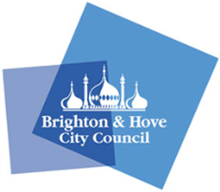
Overview of B&H Relationships & Sex Education Curriculum for Reception to Y6
Year groups | Lesson 1 | Lesson 2 | Lesson 3 | Lesson 4
R | What can we do to look after our bodies?  Can you label all the parts of our bodies including personal and private parts? | What do we need to grow up healthy?  Why do we need friends? | How can we look after ourselves and our bodies at school?
1 | What makes a family? How do babies grow into children? | What keeps our bodies healthy as we grow? | Can you label all the parts of our bodies including personal and private parts? *  How do we keep our bodies safe?
2 | Do bodies come in all shapes and sizes?  What do we love about our bodies?  Why is it wrong to tease someone about how they look? | How do can you tell if animals are male or female?  How do animals have babies?  Why are male and female bodies different?* | What makes a good friend?  Does it matter if our friends are boys or girls?  Is there more than one way to be a boy or a girl?
3 | What are the names of female and male personal and private body parts and what do they do? Do bodies come in all shapes and sizes? | How can we feel good about ourselves?  Should we all look the same?  How do I pick myself up if I feel down? | What is a family?  Are all families the same?  How do families change? | What is a healthy relationship?  When does friendship feel good?
4 | How do human babies begin?  What are the different ways that families begin? | What happens to my body as I grow and change from a child to a grown up? | How do the changes at puberty affect how young people might feel? | What life skills will I need as I grow and change?  How can I keep healthy and safe as I grow and change?
5 | What is embarrassment?  How can we manage this feeling?  What is the link between how our relationships change as we grow up and feeling embarrassed? | What does puberty mean?  How do children grow and change into young adults? | What is puberty like for most girls and most boys?  What is exciting about growing up?  How can we grow confidence to talk about puberty and ask questions? | What do young people need to do to look after themselves during puberty ?(hygiene)
6 | What is body image?  How do images in the media affect how we feel about ourselves? | When do friendships feel positive online and face to face?  How can I stay safe online? | How can I stay safe online? What is safe to share online?  How can I find out information about growing up safely? | What do you know about the changes at puberty for most girls and most boys?  How do you feel about puberty?  What questions do you have?  How do human babies start?  How are human babies born?

